QuickBite Delivery Analytics

Problem Statment
Peak Date Demand & Revenue Concentration Assessment: Analyze order volume spikes and transactional revenue patterns across calendar dates to evaluate platform load management and delivery reliability during high-demand windows.

1. Daily Demand & Order Volume Concentration
This section identifies how order volume varies across calendar dates and highlights dates with unusually high demand.
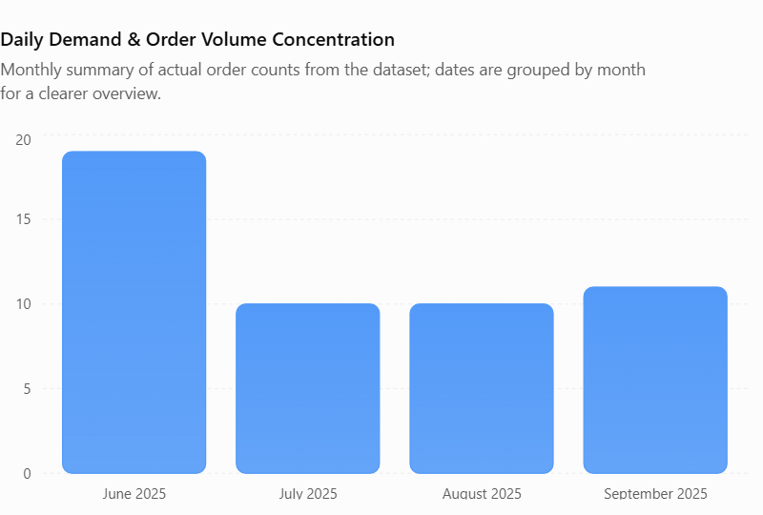

Business insights
- Dates with the highest order counts represent potential demand spikes.
- Dates with three or more orders are classified as high-demand days under your selected rule.
- Dates above the average daily order count may require additional delivery partners and restaurant support.
- If a large share of all orders falls on a few dates, QuickBite may need more flexible operational planning.
Business implication: Identifying high-demand dates helps the platform prepare for sudden increases in orders and reduce the risk of delayed fulfilment.
2. Daily Revenue Concentration & Net Realization
This section evaluates delivered order value after discounts to identify the dates contributing the most financial value. Business insights
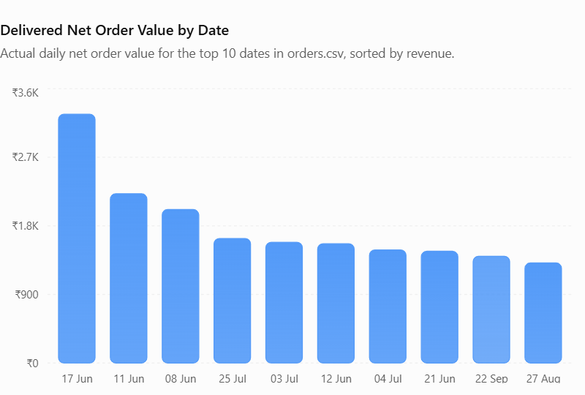
Business insights
- The highest-revenue date identifies the strongest date in terms of delivered net order value.
- Revenue peaks may result from more orders, higher-value orders, or lower discounts.
- Comparing daily revenue with the average helps identify commercially important dates.
- Discount expenditure on multi-order dates helps evaluate how much promotional value was offered during busy periods.

Business implication: QuickBite should examine order volume and average order value together. A date with fewer but higher-value orders may generate more revenue than a date with many smaller orders.

3. Delivery Reliability During Demand Peaks
This section investigates whether busy dates are associated with longer delivery times and more service-level breaches.
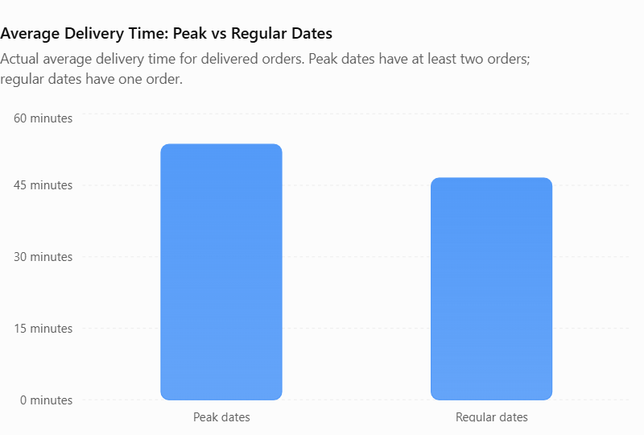
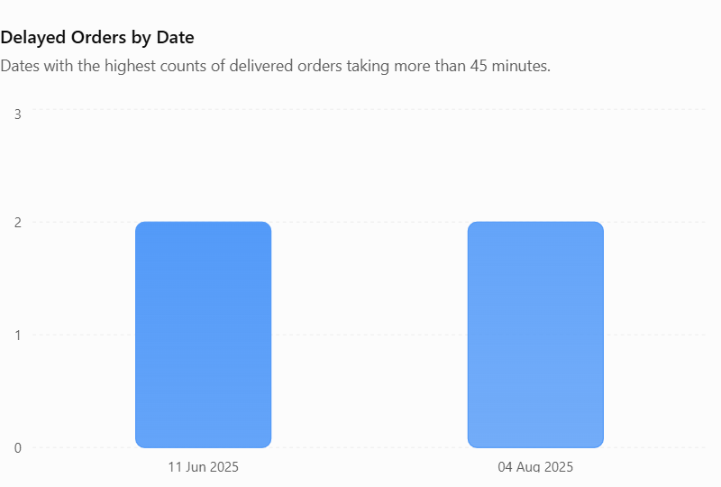
Business insights
- Higher average delivery times on peak dates may indicate capacity constraints or restaurant preparation delays.
- Dates with more orders exceeding 45 minutes deserve further investigation.
- Orders exceeding 60 minutes indicate severe delays under your chosen threshold.
- If delays also occur on regular dates, the cause may involve routing, restaurant readiness, or delivery-partner availability rather than demand alone.
Business implication: QuickBite should compare delivery performance across demand categories before deciding whether additional staffing or process changes are needed.

4. Order Fulfillment & Cancellation Patterns
This section assesses whether demand spikes affect successful order completion.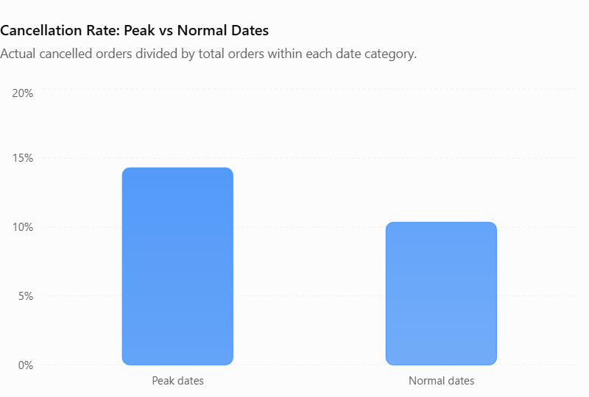

Business insights
- A higher cancellation rate on peak dates may suggest restaurant capacity issues or insufficient delivery resources.
- Pending orders highlight dates when fulfillment requires additional attention.
- Customer-segment participation on busy dates can reveal which segments contribute most to peak demand.
- Cancellation rate should be interpreted alongside sample size; one cancellation out of two orders produces a 50% rate, but the sample is small.
Business implication: Monitoring pending and cancelled orders helps QuickBite identify fulfillment problems that order volume and revenue alone cannot reveal.

5. Date Rankings & Cumulative Revenue Concentration
This section ranks the highest-value dates and measures how much revenue is contributed by the leading dates.
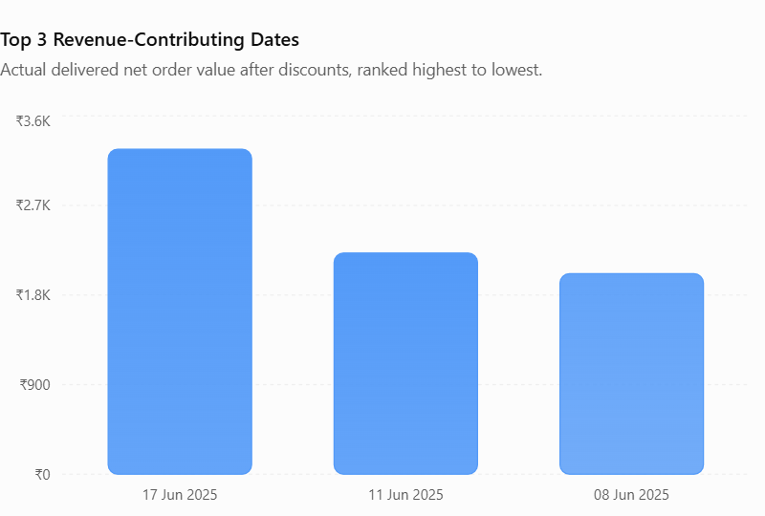

Business insights
- Ranking dates by order volume identifies the busiest periods.
- Ranking dates by delivered net order value identifies the strongest revenue-generating periods.
- The top-three revenue contribution indicates whether delivered order value is concentrated in a small number of dates.
- Cumulative revenue analysis shows how quickly the leading dates account for total delivered net order value.
Business implication: The platform can prioritize operational reviews around dates with both high demand and high revenue, while checking that service quality remains acceptable.
Key Business Recommendations
Demand-based capacity planning
Use observed order-volume peaks to schedule delivery partners and coordinate restaurant readiness.
Delivery-time monitoring
Investigate dates with high delayed-order counts and severe delivery-time breaches.
Improve fulfillment reliability
Monitor cancellation and pending-order rates to identify problems during high-demand periods.
Track revenue concentration
Compare the contribution of the top three revenue dates with total delivered net order value.

Conclusion
The Peak Date Demand & Revenue Concentration Assessment helps QuickBite understand how order activity, delivered net order value, and fulfillment reliability vary across calendar dates. Identifying high-demand and high-revenue dates enables better capacity planning, delivery monitoring, and fulfillment management.
The main objective is to determine whether increased demand coincides with longer delivery times, cancellations, or pending orders. By combining these metrics, QuickBite can identify operational weaknesses and improve the customer experience.

